Research & Test AGVs

The team created a list of AGVs to research common AGV hardware and software. This list has been compiled after online research into AGV manufacturers and their products. Most of the AGVs on the list are part of the subcategory AMRs (Autonomous Mobile Robots) and are rated for a payload around 100kg. The Omron LD-60 and the MiR100 are the main test AMRs because these are available at Fontys. The other robots will serve as guidelines for design choices of the CoLAB.

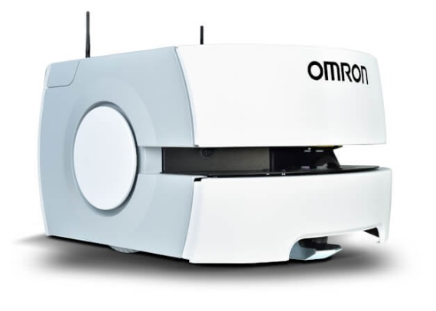

Omron, LD-60

<https://industrial.omron.eu/en/products/ld-60-90>

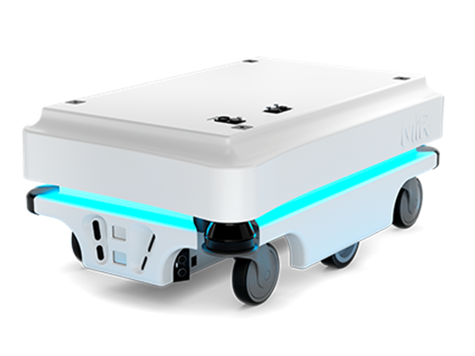

MiR, 100

<https://www.mobile-industrial-robots.com/en/solutions/robots/mir100/>

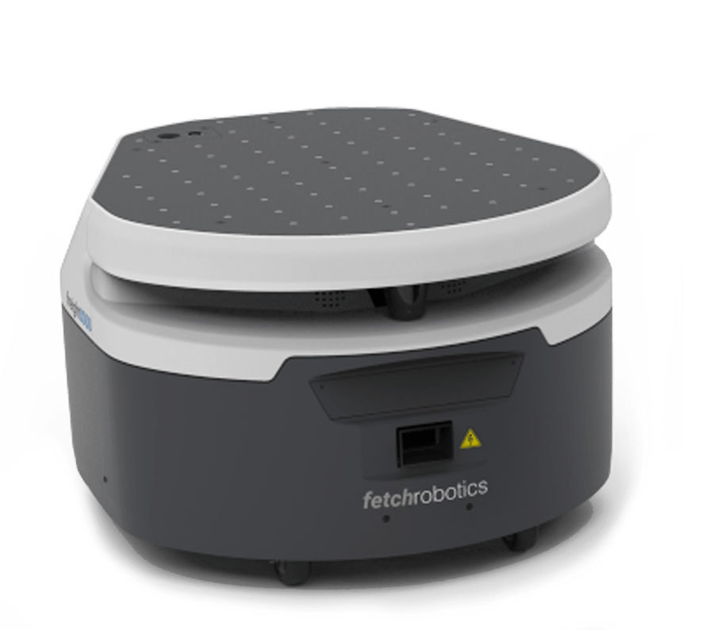

Fetch Robotics, Freight Base

<https://fetchrobotics.com/robotics-platforms/freight-base/>

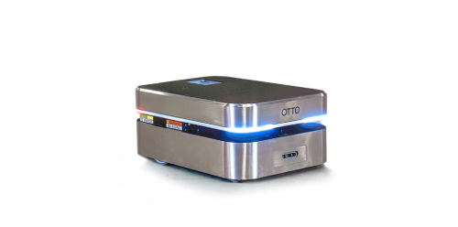

# Otto Motors, OTTO 100

<https://ottomotors.com/amrs>

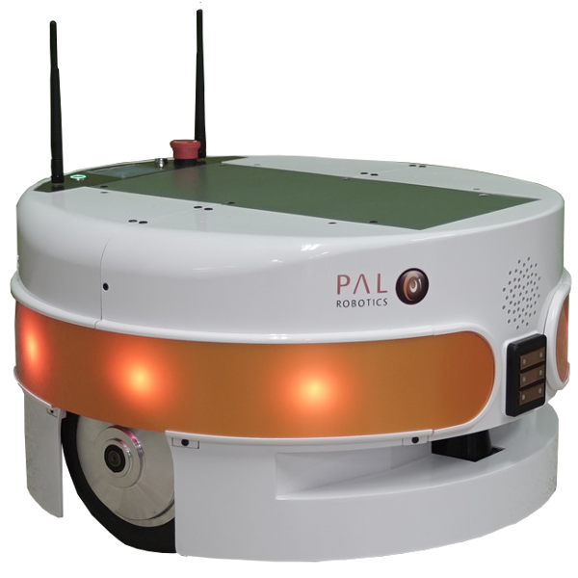

PAL Robotics, Tiago Base

<https://pal-robotics.com/robots/tiago-base/>

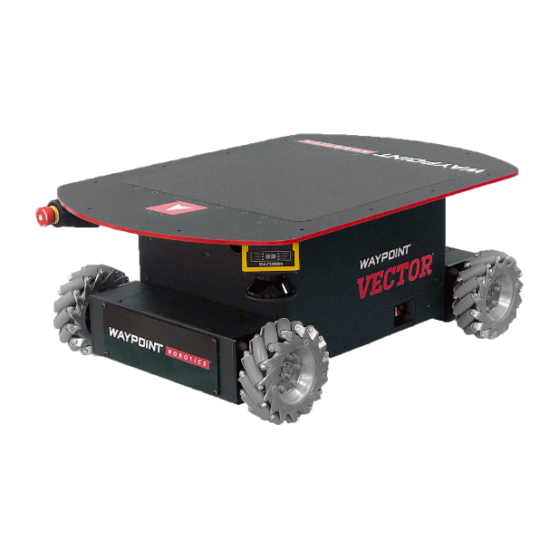

Waypoint Robotics, Vector™

[https://waypointrobotics.com/  
vector-robotic-mobility-platform/](https://waypointrobotics.com/vector-robotic-mobility-platform/)

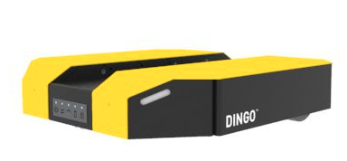

Clearpath, DINGO

<https://clearpathrobotics.com/dingo-indoor-mobile-robot/>

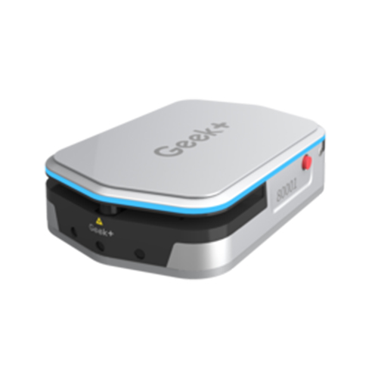

Geek+, M100

<https://www.geekplus.com/product-2/moving>

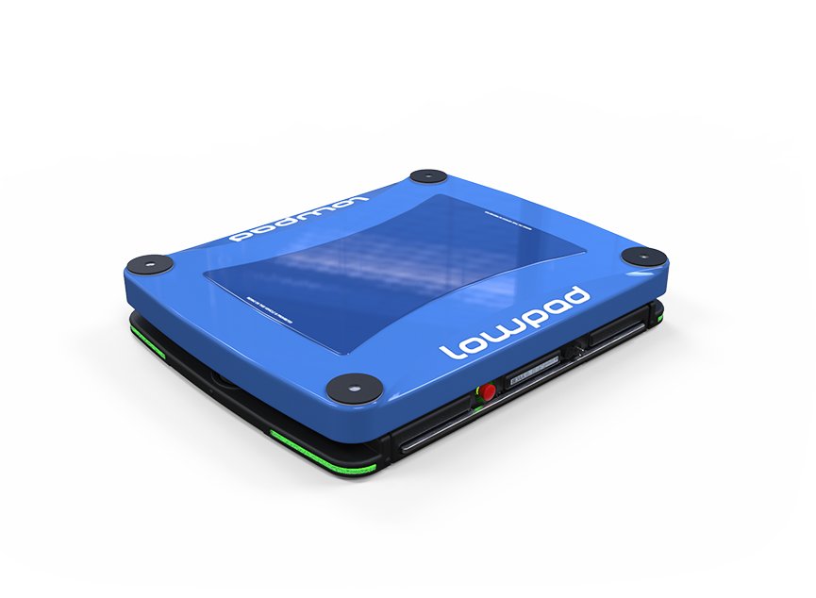

Lowpad, M

<https://www.lowpad.com/lowpad-family/lowpad-m>

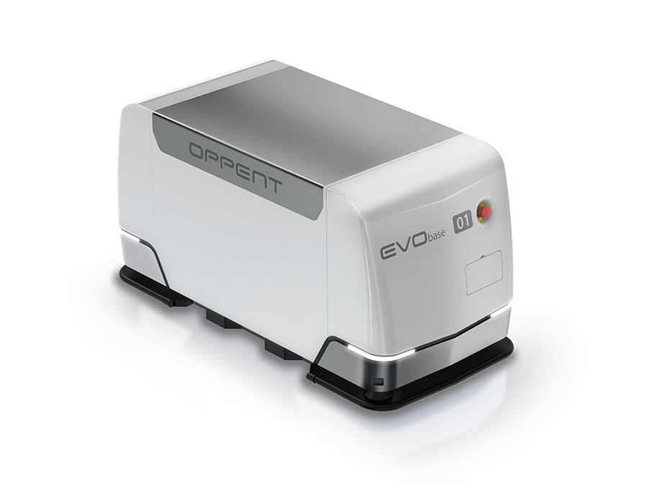

Oppent EVO, base™

<https://www.oppent-evo.com/en/prodotto/evo-base-2/>

<https://www.ifollow.fr/produits/>

Some other market leading AGV companies:

* Swisslog
* Locus
* Amazon

These companies deliver complete AGV solutions with their own infrastructure.

# Resources used for creating the Research & Test AGVs list

<https://www.robotics.org/blog-article.cfm/Autonomous-Mobile-Robots-The-Latest-Applications-and-Use-Cases-from-Leading-Suppliers-and-Users/266>

<https://www.openpr.com/news/1790541/autonomous-mobile-robots-market-expected-to-thrive-at-impressive-cagr-during-the-period-2023-swisslog-kuka-omron-adept-clearpath-robotics-vecna-mobile-industrial-robots-smp-robotics.html>